**Online Examination System**

Final Project Report

**Web Systems and Technologies**

|  |  |
| --- | --- |
| **Project Title:** | Online Examination System |
| **Submitted By:** | Muhammad Ibrahim (01-135231-062)  M Abdullah Bin Abdul Aziz (01-135231-043)  Wajhi Ur Rehman (01-135231-092) |
| **Instructor:** | Mr. Adnan Jelani |
| **Submission Date:** | 25th May 2025 |

Department of Computer Science, IT

Bahria University Islamabad

**Contents**

**1 Introduction** **3**

1.1 Problem Description 3

1.2 Objectives 3

**2 Stakeholders and Users** **3**

2.1 Students 3

2.2 Teachers 3

2.3 Admin 3

2.4 Other Stakeholders 4

**3 Feasibility Study** **4**

3.1 Advantages 4

3.2 Disadvantages 4

**4 Proposed Solution** **4**

4.1 System Description 4

4.2 Key Features 5

4.3 Benefits 5

**5 Software Requirement Specification** **5**

5.1 Functional Requirements 6

5.2 Non-Functional Requirements 6

**6 System Design Specification** **7**

6.1 System Architecture 7

6.2 Database Design 7

6.3 Module Design 7

6.4 Data Flow Diagram 8

6.5 Security Design 8

6.6 Technologies and Tools 8

**7 Use Case Diagram and User Stories** **9**

7.1 Use Case Diagram 9

7.2 User Stories 9

7.2.1 Student 9

7.2.2 Teacher 9

7.2.3 Admin 9

**8 Frontend Design** **9**

8.1 Technologies Used 9

8.2 Key Pages 10

8.3 Wireframes and Screenshots 10

**9 Project Plan** **10**

**10 Implementation** **10**

10.1 Backend Development 10

10.2 Frontend Integration 11

10.3 Deployment 11

10.4 Challenges and Solutions 11

**11 Testing** **11**

11.1 Test Cases 12

11.2 Tools Used 12

11.3 Test Results 12

**12 References** **12**

**13 Conclusion** **13**

# Introduction

## Problem Description

Traditional examination systems rely heavily on manual processes, resulting in inefficiencies, human errors, and logistical challenges such as paper-based grading and scheduling conflicts. The Online Examination System is a web-based application designed to address these issues by providing a secure, efficient, and user-friendly platform for conducting online quizzes and exams. Developed using PHP, MySQL, HTML, CSS, and JavaScript, and hosted on WAMP/XAMPP servers, the system reduces manual workload, ensures real-time result generation, and supports digital transformation in educational assessments at Bahria University Islamabad.

## Objectives

* Develop a secure platform for online exams with role-based access for admins, teachers, and students.
* Enable real-time result generation and performance tracking.
* Ensure accessibility with minimal internet bandwidth requirements.
* Provide a user-friendly interface with a black-themed design.

# Stakeholders and Users

## Students

* Register and log in to access the system.
* Attempt exams listed on the homepage and submit answers.
* View exam history, scores, and overall rankings to track performance.

## Teachers

* Create, modify, and manage question papers for exams.
* View individual and overall test results to evaluate student performance.

## Admin

* Manage user accounts (add/remove teachers, students).
* Configure exam settings and schedules.
* View user feedback to improve system functionality.

## Other Stakeholders

* **Department of Computer Science**: Ensures alignment with academic goals.
* **IT Support Staff**: Manages server deployment and maintenance.
* **University Administration**: Supports adoption for institutional use.

# Feasibility Study

## Advantages

* **Accessibility**: Operates on minimal internet bandwidth, suitable for diverse network conditions in Pakistan.
* **Efficiency**: Supports multiple authorized users for seamless exam management.
* **Security**: Implements encrypted authentication to protect user data.
* **Improvement**: Includes a feedback system for continuous system enhancement.
* **Cost-Effective**: Uses free tools (WAMP/XAMPP, PHP, MySQL), minimizing expenses.

## Disadvantages

* **Connectivity**: Requires stable internet for optimal performance.
* **Setup**: Initial server configuration may need technical expertise.
* **Security Risks**: Potential vulnerabilities to cyber threats if not properly maintained.
* **Scalability**: Limited by WAMP/XAMPP’s local server capabilities.

# Proposed Solution

## System Description

The Online Examination System is a web-based application built using PHP and MySQL, hosted on WAMP/XAMPP servers. It supports secure user authentication, exam creation, question management, real-time result generation, and performance tracking, with a responsive frontend designed using HTML, CSS, and JavaScript.

## Key Features

* Secure login and role-based access for students, teachers, and admins.
* Question paper creation, updating, and deletion for teachers.
* Exam attempt and submission functionality for students.
* Real-time result generation with ranking system.
* Feedback system for user suggestions.
* Admin tools for user and exam management.

## Benefits

* Streamlined exam process, reducing manual effort.
* Intuitive, black-themed interface for enhanced user experience.
* Real-time analytics for performance tracking.
* Cost-effective deployment using open-source technologies.

# Software Requirement Specification

## Functional Requirements

|  |  |  |
| --- | --- | --- |
| **ID** | **Feature** | **Description** |
| FR1 | User Authentication | Students, teachers, and admins can register and log in securely with role-based access. |
| FR2 | Question Management | Teachers can create, update, and delete question papers. |
| FR3 | Exam Attempt | Students can attempt exams listed on the homepage and submit answers. |
| FR4 | Result Generation | System generates real-time results and rankings for students. |
| FR5 | Feedback System | Users can submit feedback for system improvement. |
| FR6 | Admin Management | Admin can manage users, exams, and view feedback. |
| FR7 | Exam History | Students can view their previous exam history and scores. |

Table 1: Functional Requirements

## Non-Functional Requirements

|  |  |  |
| --- | --- | --- |
| **ID** | **Category** | **Description** |
| NFR1 | Performance | System must respond to user actions within 2 seconds. |
| NFR2 | Reliability | 99% uptime on local servers with backup mechanisms. |
| NFR3 | Security | Encrypted data and secure authentication to prevent unauthorized access. |
| NFR4 | Usability | Intuitive interface for students, teachers, and admins. |
| NFR5 | Compatibility | Supports Chrome, Firefox, Edge browsers. |
| NFR6 | Scalability | Handles multiple users within institutional limits. |
| NFR7 | Accessibility | Operates on minimal internet bandwidth for broader reach. |

Table 2: Non-Functional Requirements

# System Design Specification

## System Architecture

The Online Examination System adopts a three-tier client-server architecture to ensure modularity and scalability within the constraints of a local WAMP/XAMPP server. The architecture comprises:

* **Presentation Layer**: Built with HTML5, CSS3, and JavaScript, delivering a black-themed, responsive interface for students, teachers, and admins. It communicates with the server via HTTP requests and AJAX calls.
* **Application Layer**: Implemented using PHP 8.2, handling business logic such as user authentication, exam management, and result processing.
* **Data Layer**: Powered by MySQL 8.0, storing user data, exam details, questions, results, and feedback in relational tables.

## Database Design

The MySQL database consists of the following key tables with relationships:

* **Users** (user_id, username, password, role, email): Stores student, teacher, and admin credentials.
* **Exams** (exam_id, title, teacher_id, date, duration): Stores exam metadata.
* **Questions** (question_id, exam_id, text, option1, option2, option3, option4, correct_answer): Stores exam questions.
* **Results** (result_id, student_id, exam_id, score, timestamp): Stores student scores.
* **Feedback** (feedback_id, user_id, comment, timestamp): Stores user feedback.

Primary keys (e.g., user_id, exam_id) and foreign keys (e.g., teacher_id in Exams, exam_id in Questions) ensure data integrity.

|  |  |  |  |  |
| --- | --- | --- | --- | --- |
| **Entity** | **Attributes** | **Primary Key** | **Foreign Key** | **Relationship** |
| Users | user_id, username, password, role, email | user_id | None | Referenced by Exams, Results,  Feedback |
| Exams | exam_id, title, teacher_id, date,  duration | exam_id | teacher_id (Users) | References  Users; Referenced by  Questions, Re-  sults |
| Questions | question_id,  exam_id, text, option1, option2, option3, option4, correct_answer | question_id | exam_id (Exams) | References Exams |
| Results | result_id, student_id, exam_id, score,  timestamp | result_id | student_id  (Users),  exam_id (Exams) | References Users, Exams |
| Feedback | feedback_id, user_id, comment, timestamp | feedback_id | user_id (Users) | References Users |

Table 3: Entity-Relationship Diagram Table

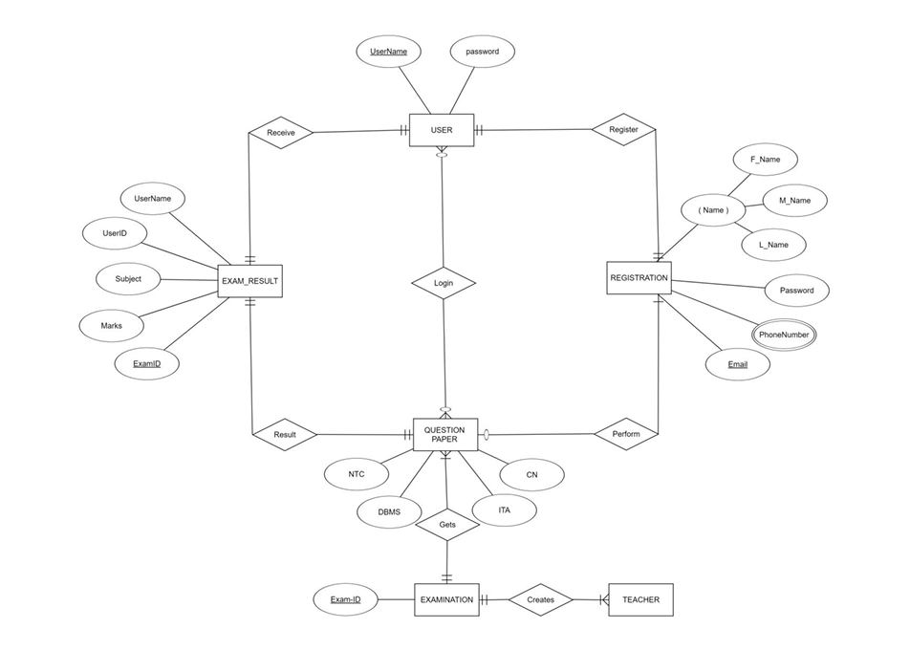

Figure 2: Entity-Relationship Diagram

## Module Design

The system is divided into the following modules:

* **Authentication Module**: Manages user registration, login, and role-based access using PHP sessions and MySQL queries.
* **Exam Management Module**: Enables teachers to create, update, and delete exams and questions via PHP forms and MySQL CRUD operations.
* **Result Processing Module**: Calculates scores and generates rankings using PHP algorithms, storing results in MySQL.
* **Feedback Module**: Collects user input through HTML forms, processed by PHP and stored in MySQL.
* **Frontend Module**: Delivers dynamic, black-themed interfaces with JavaScript for interactivity (e.g., exam timers) and CSS for responsiveness.

## Security Design

Security measures include:

* **Encryption**: HTTPS for secure data transmission.
* **Authentication**: Password hashing with bcrypt in PHP.
* **Input Validation**: Sanitization to prevent SQL injection and XSS attacks.
* **Access Control**: Role-based permissions enforced via PHP session management.

## Technologies and Tools

* **Development**: PHP 8.2, MySQL 8.0, HTML5, CSS3, JavaScript.
* **Server**: WAMP/XAMPP for local hosting.
* **Tools**: GitHub (version control), ClickUp (project management), PHPUnit (unit testing), Figma (UI design).

# Use Case Diagram and User Stories

## Use Case Diagram

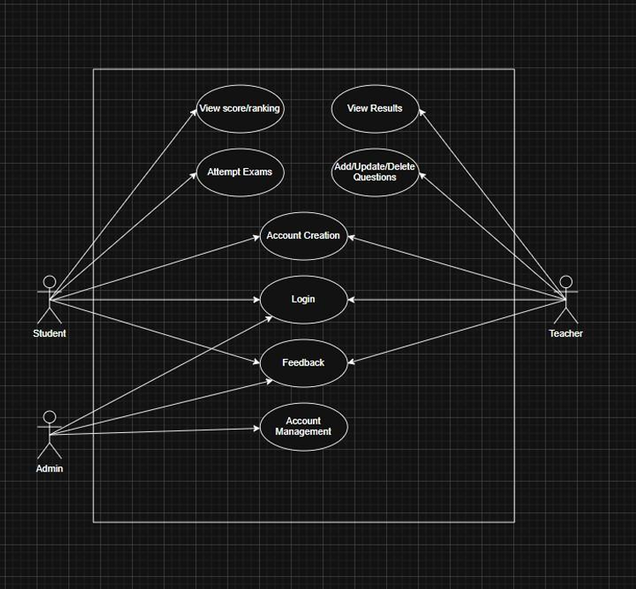

Figure 4: Use Case Diagram

## User Stories

### Student

* As a student, I want to log in and attempt exams listed on the homepage so that I can complete assessments efficiently.
* As a student, I want to view my exam history and rankings to track my academic progress.

### Teacher

* As a teacher, I want to create and manage question papers to prepare exams for my students.
* As a teacher, I want to view test results to evaluate student performance and provide feedback.

### Admin

* As an admin, I want to manage user accounts and exam settings to ensure smooth system operation.
* As an admin, I want to view user feedback to identify areas for system improvement.

# Frontend Design

The frontend was developed using HTML, CSS, and JavaScript, delivering a clean, responsive, black-themed interface for all roles.

## Technologies Used

* **HTML**: Provides semantic structure.
* **CSS**: Manages styling, layout, and responsiveness.
* **JavaScript**: Enables dynamic content and interactivity.

## Key Pages

* **Homepage**: Navigation links and system mission.
* **Student Dashboard**: Displays exams with details and start options.
* **Teacher Dashboard**: Facilitates question paper management and result viewing.
* **Admin Dashboard**: Tools for user and exam management.
* **Login Page**: Role-based authentication.
* **About Page**: System purpose and benefits.

## Wireframes and Screenshots

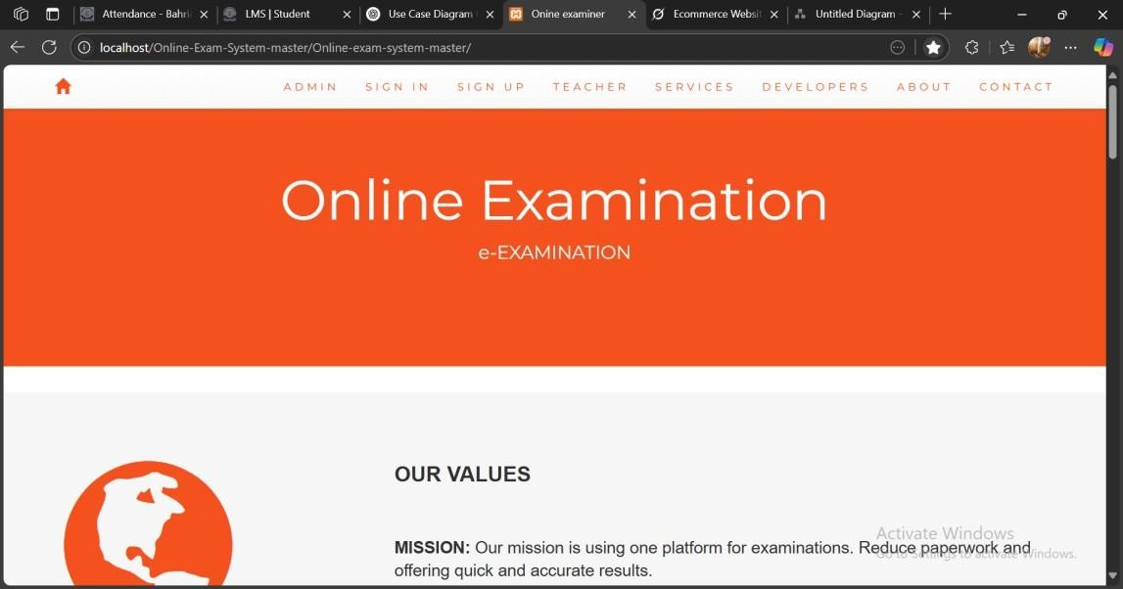

*Figure 2 Homepage*

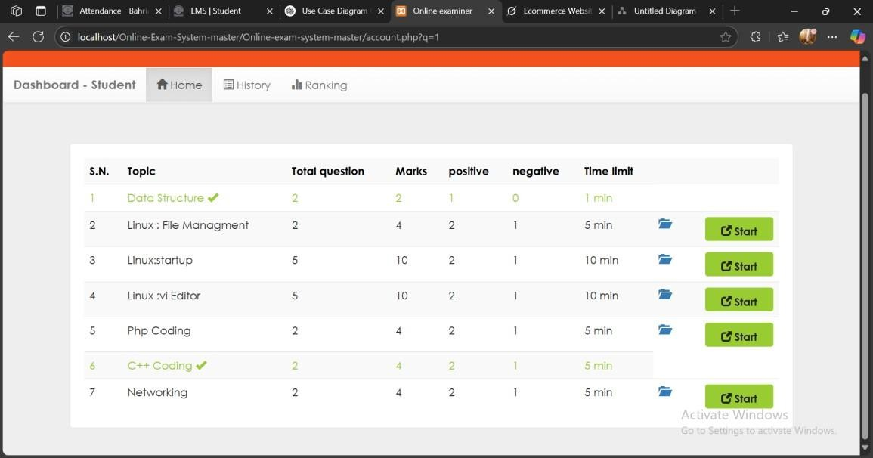

*Figure 3 Student Dashboard*

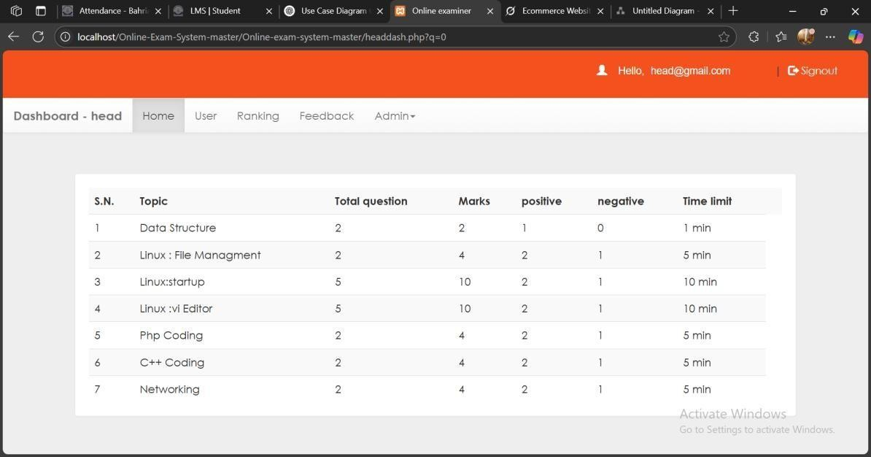

*Figure 4 Admin Dashboard*

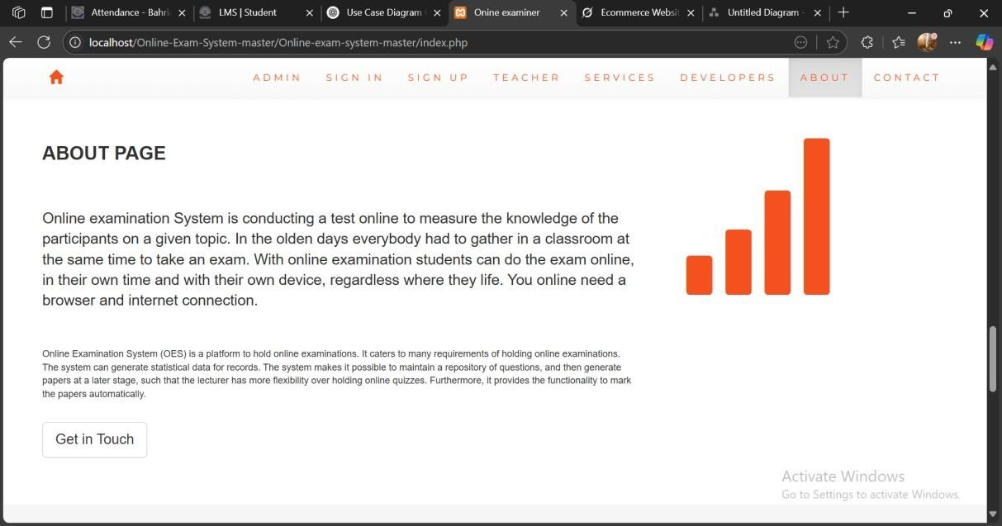

*Figure 5 About page*

# Project Plan

The project was executed over 4 weeks (April 27–May 18, 2025), managed using ClickUp.

## Work Breakdown Structure (WBS)

The Work Breakdown Structure (WBS) hierarchically organizes the project tasks into manageable components, ensuring clarity in responsibilities and timelines.

|  |  |  |  |  |
| --- | --- | --- | --- | --- |
| **WBS**  **ID** | **Task** | **Subtask** | **Assigned To** | **Duration** |
| 1.0 | Project Initiation |  | Muhammad  Ibrahim | 2 days |
| 1.1 |  | Define scope and ob-  jectives | Muhammad  Ibrahim | 1 day |
| 1.2 |  | Set up tools (GitHub, ClickUp) | Wajhi Ur Rehman | 0.5 days |
| 1.3 |  | Install  WAMP/XAMPP | M Abdul-  lah | 0.5 days |
| 2.0 | Requirements Analy-  sis |  | Muhammad  Ibrahim | 3 days |
| 2.1 |  | Gather functional requirements | Muhammad  Ibrahim | 1 day |
| 2.2 |  | Define non-functional requirements | Wajhi Ur Rehman | 1 day |
| 2.3 |  | Document SRS | M Abdul-  lah | 1 day |
| 3.0 | System Design |  | Wajhi Ur Rehman | 4 days |
| 3.1 |  | Design three-tier architecture | Wajhi Ur Rehman | 1 day |
| 3.2 |  | Create database  schema | M Abdul-  lah | 1 day |
| 3.3 |  | Design UI wireframes (Figma) | Muhammad  Ibrahim | 2 days |
| 4.0 | Development |  | All Mem-  bers | 8 days |
| 4.1 |  | Frontend Development | Muhammad  Ibrahim | 4 days |
| 4.1.1 |  | Develop HTML5  structure | Muhammad  Ibrahim | 1 day |
| 4.1.2 |  | Style with CSS3 | Muhammad  Ibrahim | 2 days |
| 4.1.3 |  | Add JavaScript interactivity | Muhammad  Ibrahim | 1 day |
| 4.2 |  | Backend Development | Wajhi Ur Rehman | 3 days |
| 4.2.1 |  | Set up MySQL  database | Wajhi Ur Rehman | 1 day |
| 4.2.2 |  | Develop PHP scripts | Wajhi Ur Rehman | 2 days  Page 12 |
| 4.3 |  | Integration | M Abdul-  lah | 1 day |

## Timeline

The project was executed over 4 weeks (April 27–May 18, 2025), managed using ClickUp.

* **Week 1**: Setup (GitHub, WAMP/XAMPP), requirements, UI design.
* **Week 2**: Frontend (HTML, CSS, JavaScript) and backend (PHP, MySQL).
* **Week 3**: Integration and testing.

**Week 4**: Bug fixing, deployment, documentation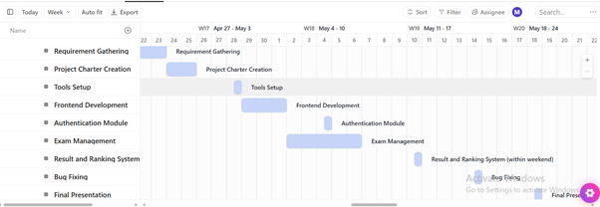

Figure 8: Gantt Chart

# Implementation

## Backend Development

Developed using PHP and MySQL on WAMP/XAMPP:

* **Database**: MySQL tables for users, exams, questions, results, feedback.
* **Authentication**: PHP scripts for secure login/signup.
* **Exam Management**: PHP functions for CRUD operations.
* **Result Processing**: Algorithms for score calculation.

## Frontend Integration

Integrated with backend via PHP scripts:

* **Dynamic Content**: JavaScript for timers and validation.
* **Responsive Design**: CSS media queries for compatibility.
* **UI**: Black-themed dashboards.

## Deployment

Deployed on WAMP/XAMPP:

* Configured PHP 8.2 and MySQL 8.0.
* Imported database schema.
* Tested server stability.

## Challenges and Solutions

* **Challenge**: API mismatches.
* **Solution**: Unit tests with PHPUnit, Postman for API validation.
* **Challenge**: Security concerns.
* **Solution**: HTTPS, bcrypt hashing.

# Testing

## Test Cases

|  |  |  |  |  |
| --- | --- | --- | --- | --- |
| **ID** | **Test Case** | **Objective** | **Expected Result** | **Status** |
| TC01 | User Login | Validate login | Dashboard loads | Passed |
| TC02 | Exam Attempt | Submit answers | Results generated | Passed |
| TC03 | Question Management | Create questions | Questions added | Passed |
| TC04 | Result Viewing | Display results | Results shown | Passed |
| TC05 | Feedback Sub-  mission | Record feedback | Feedback saved | Passed |
| TC06 | Admin Management | Manage users | Accounts updated | Passed |

Table 3: Functional Test Cases

## Tools Used

* **GitHub**: Version control.
* **ClickUp**: Task tracking.
* **PHPUnit**: Backend testing.
* **Browser Tools**: Frontend testing.

## Test Results

All test cases passed, confirming functionality, security, and usability.

# References

* W3Schools. PHP Tutorial. <https://www.w3schools.com/php/>
* MySQL Documentation. <https://dev.mysql.com/doc/>
* W3Schools. JavaScript Tutorial. <https://www.w3schools.com/js/>
* W3Schools. CSS Tutorial. <https://www.w3schools.com/css/>
* Stack Overflow. <https://stackoverflow.com/>
* PHPUnit Documentation. <https://phpunit.de/documentation.html>

# Conclusion

The Online Examination System was successfully developed and deployed, delivering a secure, efficient platform using PHP, MySQL, HTML, CSS, and JavaScript. Managed with ClickUp, it met all requirements, including secure authentication, real-time results, and black-themed dashboards. Challenges were addressed through rigorous testing. The system supports Bahria University’s digital transformation goals.

**Team Members**: Muhammad Ibrahim, M Abdullah Bin Abdul Aziz, Wajhi Ur Rehman

**Instructor**: Mr. Adnan Jelani

**Submission Date**: 25th May 2025